**Assignment 3**

**Operation Research**

**BTech Sem IV (20-21 Batch)**

Q1. Compare the solution for the following problems obtained by a) Northwest corner, b) Least cost and c) Vogel’s method:



Q2. Find the Initial Basic Feasible Solution using the a) Northwest corner, b) Least cost and c) Vogel’s method. Determine the optimal solution by MODI Method.

1. Balanced TP

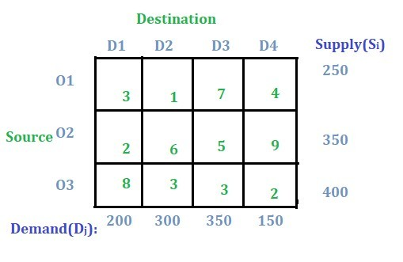

1. Balanced TP (Degeneracy)

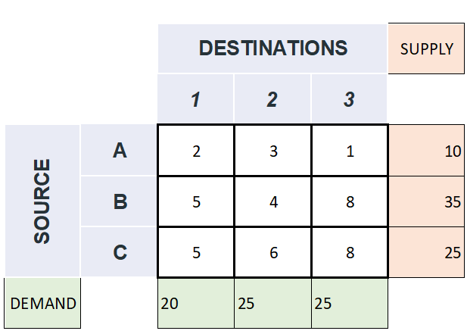

1. Unbalanced TP

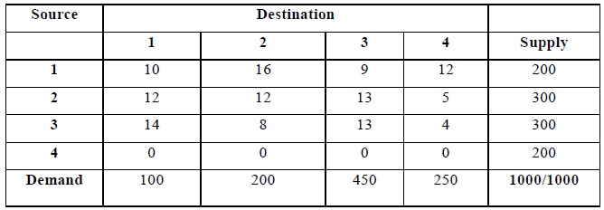

1. Unbalanced TP

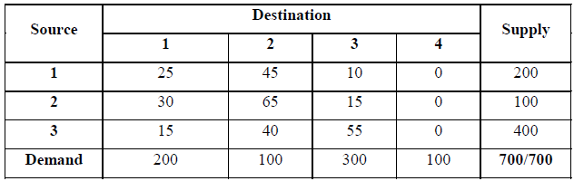

Q3. Obtain the IBF solution and check degeneracy in TP. Determine the solution for the degenerate TP.

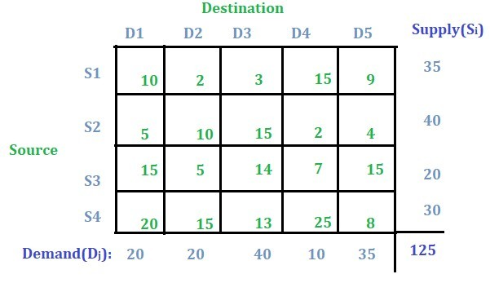

Q4. Solve the assignment problem using the Hungarian method.

a)

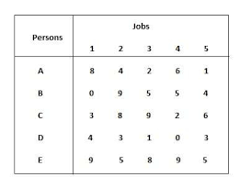

b)

